Domino’s Pizza SQL Analytics
Q17) Write down some insights of Domino’s Pizza SQL Analytics
Ans) a) There are total 500 unique orders of Domino’s Pizza
b) The Total Revenue of Domino’s Pizza is 899732 and Average Order Value is 1799.4640
c) The highest monthly revenue is of Month 1 with total revenue of 173675 and least is of month 2 with total revenue of 119220
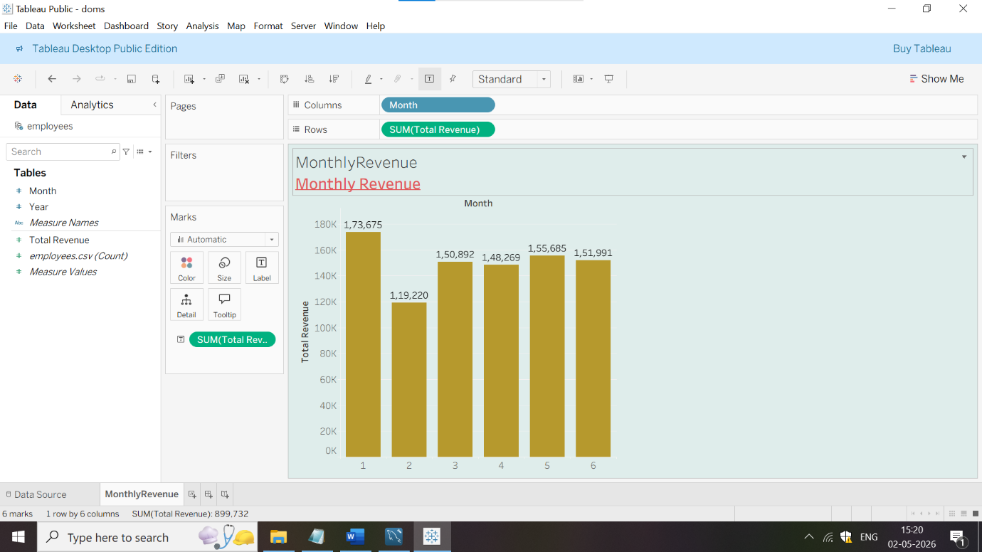
d) The highest number of orders are in Wednesday in Weekdays with total order count of 84 orders and least number of orders are on Tuesday with 67 orders

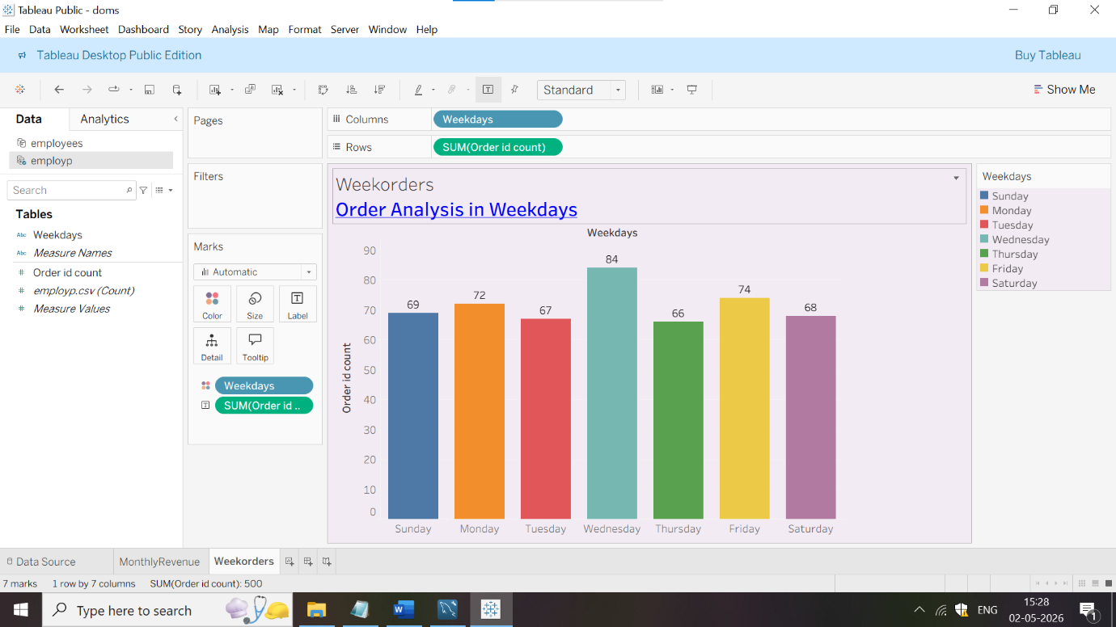

e) Paneer Makhani has the highest % of total revenue of 21.92% while peppy Paneer is the least one with % of total revenue of 14.32%.

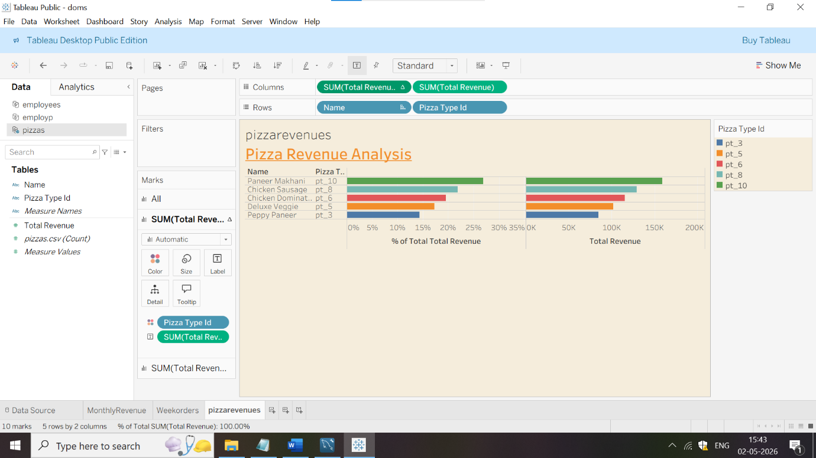

Q18) Give Some Recommendations
Ans) a) The least revenue of Domino’s Pizza is in month 2 with total revenue of 119220.Hence,in order to increase or maximize revenue,company must run some marketing campaigns or give some combo offer with pizza’s to their customers for increasing the sales or revenue
b) The highest number of Order Id count are on Wednesday with 84 orders.Company must identify what type of Pizza Veg or Non-Veg Category are more in demand with customers and can give one complimentary drink with highest selling pizza on Wednesday.It will help in retaining the customer
c) As,Paneer Makhani has the highest % of total revenue of 21.92%.Domino’s Pizza outlet must increase the quantity of Paneer Makhani so that the outlet won’t face any shortage of Paneer Makhani Pizza.

